Cell Transport Ch 7 -3

Every living cell exists in a _________________________environment.

The cell membrane regulates ____________________________ of dissolved molecules from the liquid on one side of the membrane to the liquid on the other side.

Cells can transport substances ___________________ their membrane.

__________________________________________- regulates what moves in and out of the cell
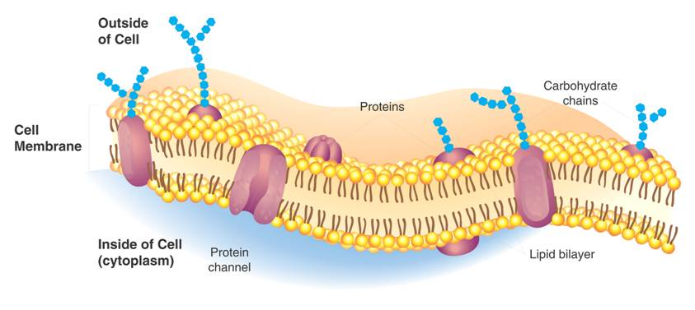
Measuring Concentration
A ______________________________ is a mixture of two or more substances.
The substances dissolved in the solution are called ___________________________and the material that does the dissolving is called the _______________________________.
_______________________________of a solution is the mass of solute in a given volume of solution, or mass/volume.

___________________________________________- a gradient is formed between the molecules at various points between the high and low areas.
Because molecules diffuse from areas of __________________________________________to areas of
__________________________________________, they move _______________________________________________.

Substances can be transported across the cell membrane in ___________________________________:
I._______________________________________- transported across the membrane _______________________________; goes __________________ concentration gradient.
Types of _____________________________________are:

A. Diffusion
Particles in a solution tend to move from an area where they are________________________________ to an area where they are___________________________________.
This process is called ______________________.
Ex. Spray perfume in the room
When the concentration of the solute is _______________ _________________________________________, the system has reached ________________________________________
Moving down the Gradient
Solute particles move from the side of the membrane with a ________________________________of solute to the side of the membrane with a lower concentration of solute. The solute particles will continue to diffuse across the membrane ___________________________________________is reached
When equilibrium is reached, solute particles __________________________________ across the membrane in both directions. Since substances move randomly across membranes they __________________________________________________

Examples of _______________________________
• Dye moving through a beaker of water
•
•
•_____________________________ - greater inside the cell and thus moves down the concentration gradient to leave the cell.
•______________________________- enters the cell by diffusion cause it is greater outside the cell than inside

The ability of a molecule to diffuse across a cell membrane depends on :
a. ______________________(tiny will move through pores in the membrane)
b. Chemical nature _______________________________
c. _____________________________________ (if it can dissolve in lipids, it can pass easily)

B. Osmosis
__________________________ is the diffusion of ________________ through a selectively permeable _________________________________.
Requires ___________________________because it is moving down the gradient.
Water will move from a ____________________________________________________________ _______________________________________

If you compare two solutions:
When concentrations of solutions _____________________________ on both sides of a membrane, the solutions are _______________________________________________________
Normal cells are in a _______________________________________.

The more concentrated solution outside the cell (more solute less water) is ___________________ _____________________________
Salt Water is a _____________________________________________ (anything over 0.9% salt for blood cells)
If a ________________________is placed in a hypertonic solution it will ________________ because water is ____________________ on the inside of the cell (cytosol) so it diffuses outside the cell______________________ _________________________________________

The more dilute solution outside the cell (more solvent/water than solute) is ______________________________________________.
If the concentration of water molecules is greater outside a cell, water diffuses inward to the cytosol and the ________________________________.
Pure water is a _______________________________________
•If an animal cell is placed in _________________________ (hypotonic) osmosis causes it to ___________________________________.
•A plant cell will swell ________________________________ because it has a cell wall which allows plants to stand upright.

Osmotic Pressure
Osmosis exerts a pressure known as ___________________ _______________________________ on the hypertonic side of a selectively permeable membrane.

Water moves into plant cells by____________________, which swell as it fills and exerts pressure to hold the plant up.
Cells in large organisms are not in danger of bursting because they are _______________________, such as blood, that are ____________________________.
Other cells are surrounded by ___________________________ that prevent the cells from expanding even under tremendous osmotic pressure. The pressure that water molecules exert ____________________________
is called _______________________________________

The ___________________________________________in freshwater protozoans ______________________________that enters the cell so they don’t gain lots of water and___________________.

___________________________________ solutions are given to patients for __________________ - swelling; to get them to lose the excess water
___________________________________ solutions are given to re-hydrate patients.
____________________________ - bursting of red blood cells,
____________________________- bursting of cells.
____________________- a condition where the _______________________ ___________________________ pulls away from the cell wall in plant cells as the cell shrinks in a Hypertonic solution. The cell wall
is rigid and does not shrink. This is why __________________________________.

C. Facilitated Diffusion
Cell membranes have protein channels that act as carriers called ______________________________making it easy for certain ____________________________________.
Used when molecules _______________________________or when they aren’t soluble in lipids.
It goes down the concentration gradient therefore ______________________________________________.

The movement of specific molecules across cell membranes from a greater concentration to a lesser one through protein channels is known as ________________________________________________.

Example:
__________________________ is too big to fit across the membrane so it needs a_____________________ to help it across.
____________________________ _______________________ proteins help molecules get through.

Although facilitated diffusion is fast and specific, it is still diffusion.
Therefore, ____________________________________will _________________________if there is a higher concentration of the particular molecules on one side of a cell membrane as compared to the other side.
________________________________________________________!!
II. Active Transport
_______________________________________________is when molecules need to move __________________________ concentration __________________________concentration therefore they go against a concentration gradient or ___________________________________________.

This requires __________________________________to move up the concentration gradient.

In _________________________________, small molecules and ions are carried across membranes by ______________________________ in the membrane. The carrier proteins are also called “__________________” because they move substances _____________________________________.
Energy use in these systems enables cells to _______________________________________ in a particular location, even when diffusion might move them in the opposite direction.
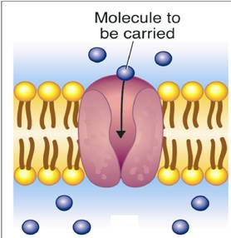
Types of Active Transport
A. Sodium _________________________________________________
- a ___________________________________moves substances across the plasma membrane
-____________________________________the concentration gradient
-Uses ____________________________
-__________________________________________to which molecules are carried by what protein
-Used to send nerve impulses and for muscle contractions.
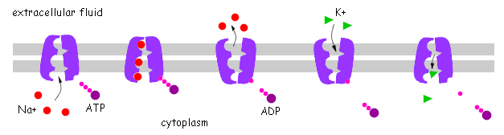
3 Sodium (Na) ions are moved out and 2 Potassium (K) ions are moved into the cell.

Some substances are too large to pass in the ways just discussed so they use other ways like
-

-

B.____________________________ - release large amounts of material ________________________________________.
The membrane of the vesicle (sac) surrounding the material fuses with the cell membrane, forcing the contents _______________________________________________.
______________________________________.
_______________________________________ made by the cell to the outside or eliminate waste products from the cell.
Recall that proteins are made on the ribosomes and packaged into vesicles by the Golgi Apparatus which are then moved out of the membrane by fusing with the cell membrane.
Ex. ___________________________________________________________

C. _____________________________________- is the process of taking material ____________ the cell by means of infoldings, or pockets, of the cell membrane.
The pocket breaks loose from the outer portion of the cell membrane and forms a vesicle within the cytoplasm. This vacuole fuses with a_______________________________ and its contents are digested.

Requires ________________________.
-
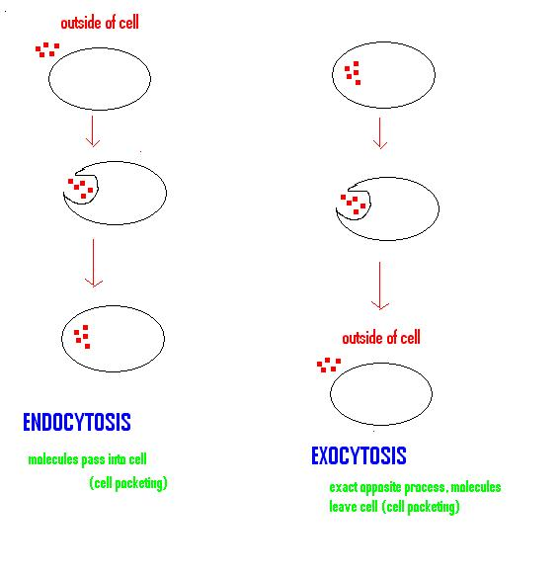

Two examples of _________________________________________ are:
•

•

In ____________________________________, extensions of cytoplasm surround a particle and package it _________ ________________________________. The cell then engulfs it. “______________________________________”
Ex. White Blood Cell engulfs bacteria or a virus

In _______________________________________, tiny pockets form along the cell membrane, _________________________________, and pinch off to form vacuoles within the cell. “____________________________”

